**Distillery Data**

Using JC and Julia’s ETL project data on Distillery, we are going to look at distillery data across the world to see rankings, ratings, locations, and more. This dataset was chosen due to JC’s love of alcohol and the distilling process.

Items of interest:

* Founding dates
* Closed dates (if applicable)
* Rankings
* Ratings based on votes, brands by votes and ratings, brands by world ranking
* Wish list frequency
* Locations, brands by location
* # of spirit and wash stills

Inspiration examples: classwork where you click on a marker, it brings up more information (Would like to use this for distillery locations, click and have it zoom in on new locations, color coded, etc.)

Classwork where you update the dashboard with multiple charts that updated from the same data set

**Mockup:**

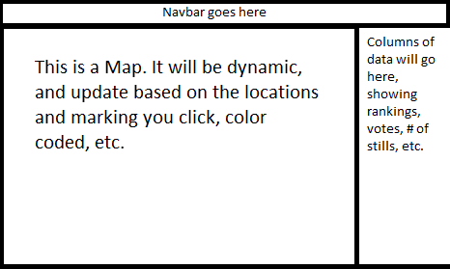

**Metadata:**

Link - <https://www.kaggle.com/koki25ando/world-whisky-distilleries-brands-dataset#Distillery.csv>

Screenshot:

